- Introduction
  - Background of Case Study
Southeast Asia is home to an extraordinary linguistic heritage, with more than 1,200 languages approximately one-fifth of all languages spoken on Earth (Ethnologue, 2023). However, this richness is facing increasingly serious threats. UNESCO’s Atlas of the World’s Languages in Danger records more than 170 languages in the region as vulnerable, endangered, or critically endangered, with several already declared extinct within living memory (Moseley, 2010). Languages such as Minangkabau, spoken by around 6.5 million people in West Sumatra; Batak Toba, with approximately 2 million speakers in North Sumatra; Iban, spoken by about 700,000 people in Sarawak, Malaysia; and Sarawak Malay, with around 500,000 speakers, represent invaluable cultural assets. Despite having millions of speakers, none of these languages are currently supported by existing digital language-learning platforms (Simons & Fennig, 2023).
Ironically, technological advancement has further exacerbated this situation. Even major platforms such as Google Translate, which supports 130 languages, and the world’s largest language-learning application with over 575 million users do not include any of these languages. This absence of digital representation creates a phenomenon known as digital invisibility, which leads younger generations to perceive their local languages as irrelevant, thereby accelerating large-scale language shift (Crystal, 2000). Meanwhile, mobile internet penetration in Southeast Asia reached 74% in 2024 (We Are Social, 2024), and the region’s EdTech market is projected to exceed USD 10.5 billion by 2025 (HolonIQ, 2023). Although the technological infrastructure is already in place, no platform currently leverages it to serve speakers of regional languages.
Tutur emerges as a direct response to this crisis. This AI-powered and gamified language-learning platform is specifically designed to serve the most underrepresented linguistic communities in ASEAN, transforming language preservation traditionally a passive effort into an active, culturally rich, and engaging daily practice.

  - Chosen SDG

SDG 4 — Quality Education | SDG 10 — Reduced Inequalities | SDG 11 — Sustainable Cities and Communities

Tutur directly supports the Sustainable Development Goals (SDGs) by democratizing access to structured and high-quality language education for underrepresented linguistic communities. Furthermore, this initiative aligns with the 2003 UNESCO Convention for the Safeguarding of the Intangible Cultural Heritage, which recognizes oral traditions and languages as essential vehicles of cultural preservation and as integral components of sustainable community development.

  - Problem Statement
The challenges faced in preserving indigenous languages in ASEAN are multidimensional and structural:
- Risk of Language Extinction: Of the more than 170 languages identified by UNESCO as being at risk in Southeast Asia, the majority lack structured digital learning resources. Fishman (1991) notes that when fewer than 30% of children within a community continue intergenerational language transmission, the language may disappear within three generations. Several of Tutur’s target languages are now approaching this critical threshold due to declining rates of intergenerational transmission.
- Market Gap: A review of the ten leading language-learning applications shows that none support indigenous ASEAN languages. Languages with fewer than one million speakers receive 93% less digital resource investment compared to global languages (Simons & Fennig, 2023). This structural bias leaves tens of millions of potential learners entirely underserved by the modern EdTech ecosystem.
- Failure of Passive Preservation: Current preservation efforts such as digital archives or recordings are largely passive, as they merely store cultural materials without actively engaging younger generations. Participatory and interactive learning models are urgently needed to revive their interest and involvement.
- Educational Inequality: Rural communities and indigenous populations across ASEAN face a double disadvantage: a shortage of qualified language educators and weakly structured curricula. This situation is further aggravated by the weakening of traditional transmission pathways through families and communities, as younger generations increasingly migrate to urban areas and shift toward national education systems.
- Cultural Decontextualization: Most existing platforms teach regional languages primarily through vocabulary and grammar without cultural context. In reality, oral literature such as pantun, folktales, and traditional songs is not merely supplementary content but the very core of the language itself (Sweeney, 1987). Platforms that separate language from its cultural context ultimately weaken the very meaning that makes these languages worth preserving.
  - Objectives
# | Objective | Description
A | Functional Platform | Develop a functional gamification-based web application that supports eight languages: Malay, Indonesian, English, Minangkabau, Javanese, Batak Toba, Iban, and Sarawak Malay.
B | AI / NLP Integration | Implement an AI- and NLP-based learning engine capable of generating and evaluating language exercises, listening tasks, and vocabulary games for low-resource ASEAN languages.
C | Culture-First Curriculum | Design a culturally centered curriculum that integrates folktales, traditional songs, and regional legends as the primary learning media, rather than merely supplementary content.
D | Community Infrastructure | Design a Native Speaker Community Hub as a planned feature to create pathways for native speakers to contribute, mentor learners, and ensure the cultural authenticity of the platform’s content.
- Review of Existing Solutions
  - Competitive Landscape Analysis
The language-learning application market is dominated by technically sophisticated platforms; however, they share a fundamental limitation: none of them support indigenous ASEAN languages. The following analysis compares Tutur with the most relevant existing platforms across nine key dimensions:

Feature | Duolingo | Ling App | HelloTalk | Drops | Tutur
Support for Indigenous ASEAN Languages | ✗ | ✗ | ✗ | ✗ | ✓
Folktale-Based Learning Lessons | ✗ | ✗ | ✗ | ✗ | ✓
Traditional Folk Song Learning Modules | ✗ | ✗ | ✗ | ✗ | ✓
Native Speaker Community Hub | ✗ | Partial | ✓ | ✗ | ✓
Gamified Matching Exercises | ✓ | ✓ | ✗ | ✓ | ✓
Audio Listening Training | ✓ | ✓ | Partial | ✓ | ✓
Language Certification | ✗ | ✗ | ✗ | ✗ | Coming Soon
Cultural Context Integration | ✗ | ✗ | ✗ | ✗ | ✓

  - Key Gaps and Limitations
    - Complete Absence of ASEAN Indigenous Languages
To date, no EdTech platform provides structured learning resources for Tutur’s four target languages: Minangkabau, Batak Toba, Iban, and Sarawak Malay, or for other regional languages. Even Ling App, which claims to offer the broadest coverage of Southeast Asian languages, supports only Standard Malay and provides no resources for regional language variants. This gap is not merely a minor omission but rather a systematic exclusion of communities with a combined speaker population exceeding 10 million people. As long as commercial platforms focus solely on languages with the largest markets, indigenous language communities will remain underserved without solutions specifically designed for them.
    - Cultural Decontextualization
Existing platforms tend to translate vocabulary and grammar without incorporating cultural context. This approach treats language merely as a neutral linguistic system, overlooking proverbs, local wisdom, and oral literary traditions such as pantun and folktales which are in fact the very essence of these regional languages. Tutur integrates language learning within cultural narratives, making the learning process far more meaningful rather than merely functional.
    - No Community-Based Validation Mechanism
No existing platform provides mechanisms for indigenous communities to contribute to, curate, or validate content. This represents a fundamental weakness in long-term sustainability models: platforms that serve regional languages must position native speakers as content creators rather than passive subjects. Without community validation, platforms risk introducing linguistic inaccuracies and cultural misrepresentations that ultimately harm the communities they intend to serve. Tutur’s planned Native Speaker Community Hub addresses this gap by making community participation a core component of the platform’s development from the outset.
    - Pricing Inaccessibility
Global EdTech platforms typically set subscription prices in USD or EUR, creating economic barriers for learners in ASEAN. At international pricing standards, monthly subscription fees can reach 8–15% of Indonesia’s minimum wage, making language learning unaffordable for the very communities that need it most. Tutur addresses this inequality through region-based pricing, which can reduce cost barriers by 60–80% compared to USD-based alternatives, ensuring that the platform remains accessible to learners from diverse economic backgrounds.
- Methodology
  - Technical Track
    - System Architecture Overview
Tutur is built on a separated full-stack architecture consisting of three independent service layers: a responsive frontend Progressive Web Application (PWA) client, a RESTful backend API, and an ML/AI inference layer. This architectural separation ensures horizontal scalability and allows each component to be developed, tested, and deployed independently without requiring a complete system refactoring.
    - Technology Stack
Layer | Technology | Purpose
Frontend | Next.js, React, TailwindCSS | A responsive PWA interface that prioritizes mobile accessibility for cross-platform reach across various devices and browsers.
Backend | Python Flask | RESTful API services, business logic, and the AI integration layer.
Database | MySQL | Structured storage for user data, learning progress, lesson content, and community records.
ML / AI | Scikit-learn, TensorFlow | NLP model training for eight regional languages, speech recognition, and answer validation.

    - ML/NLP Implementation
Tutur’s AI capabilities are built upon a multi-stage NLP pipeline specifically designed for low-resource ASEAN languages, a technically challenging domain due to the scarcity of labeled training data. The implementation follows four structured stages:
- Data Collection : Textual corpora are collected from community-contributed texts, regional publications, oral transcriptions, and publicly available datasets for each of the eight supported languages.
- Model Training : Model Training: Classification models using Scikit-learn handle intent recognition and answer validation for text-based exercises, utilizing T5-based learning algorithms.
- Supported Language Matrix : In the MVP stage, the Tutur application supports several initial languages including Malay, Indonesian, and English (as high-resource base languages), as well as Minangkabau, Javanese, Batak Toba, Iban, and Sarawak Malay as target regional languages for preservation.
    - User Flow
The main user journey through the Tutur application follows a structured and progressive learning pathway:
- Registration & Language Selection : Users create an account and select one or more target regional languages from Tutur’s available ASEAN language options.
- Tiered Learning Modules : The learning interface presents modules organized by proficiency levels Beginner, Intermediate, and Advanced allowing users to progress at their own pace.
- Diverse Exercise Types : At each level, users can access four types of exercises: Text-Based Q&A (with NLP validation), Folktale or Folk Song Comprehension, and Audio Listening Training.
- Cultural Immersion Content : Urban Legend and Folk Song modules deliver language learning through authentic regional folktales and traditional songs, serving as a distinctive cultural differentiator of Tutur compared to competing platforms.
- Premium Content Access : Users can upgrade to subscription tiers (Basic / Pro / Master) through a localized subscription system to access the platform’s full set of features.

  - GitHub Repository
Github Organization | https://github.com/MiDev-Tutur
Frontend Repository | https://github.com/MiDev-Tutur/tutur-frontend.git
Backend Repository | https://github.com/MiDev-Tutur/tutur-backend.git

- Results
  - Objectives Assessment
The following table summarizes the development progress of Tutur toward the objectives outlined in Point 1.4 :
Objective | Status | Evidence
Multilingual web application (8 languages) | Completed | A live prototype has been implemented and is fully functional.
Authentication (Login & Registration) | Completed | JWT authentication has been fully implemented.
Language selection interface (5 indigenous languages) | Completed | Live selector available for 5 ASEAN indigenous languages.
Tiered learning structure (3 levels) | Completed | Beginner / Intermediate / Advanced modules are active.
Text-based Q&A exercises with NLP | Completed | NLP validation is active for learner responses.
Urban Legend Module (Folktales) | Completed | Read & Test functionality available for 5 regional legends.
Folk Song Module with time-stamped lyrics | Completed | YouTube integration and lyric synchronization implemented.
Listening comprehension module | Completed | Audio content with comprehension questions is operational.
Native Speaker Community Hub | In Progress | Architecture designed; API contracts defined.
Badge achievement system | In Progress | Architecture ready; UI implementation currently underway.
User profile, XP system & streak tracking | In Progress | XP tracking, daily streaks, and social-follow integration implemented.
Language certification module | Planned | Included in the product roadmap; design phase has begun.

  - Key Technical Achievements
- Successful NLP Model Training : Successfully trained NLP models for five low-resource ASEAN regional languages that previously lacked large-scale digital training corpora.
- Culture-Based Content Architecture : Implemented a culture-centered content architecture in which vocabulary acquisition is directly embedded within folktale narratives and traditional music as the primary learning media, rather than as supplementary content. This approach represents a fundamental differentiator of Tutur from all existing platforms.
- Multimodal Cultural Learning Modules : Successfully integrated two culturally distinct learning modalities: Urban Legends (folktales) with Read & Test functionality, and Regional Songs (folk music) with time-synchronized lyrics and YouTube integration as core features of the platform.
- Responsive Mobile-First Design : Achieved a mobile-first responsive design using Next.js and TailwindCSS, ensuring accessibility across multiple devices without requiring downloads from app stores through the use of Progressive Web App (PWA) technology.
- Localized Payment System : Integrated the Midtrans payment gateway with localized pricing, successfully reducing cost barriers for learners by 60–80% compared to USD-based application alternatives.
- Scalable Backend Architecture : Designed a backend architecture prepared for future microservices expansion, enabling support for upcoming features such as community participation and language certification without requiring a complete architectural overhaul.

- Prototype Showcase
The following screenshots illustrate the core features implemented in Tutur. All screenshots are taken from the functional prototype currently running at http://tutur-app.my.id/. The figure captions explain the strategic value of each feature within the context of ASEAN language preservation.
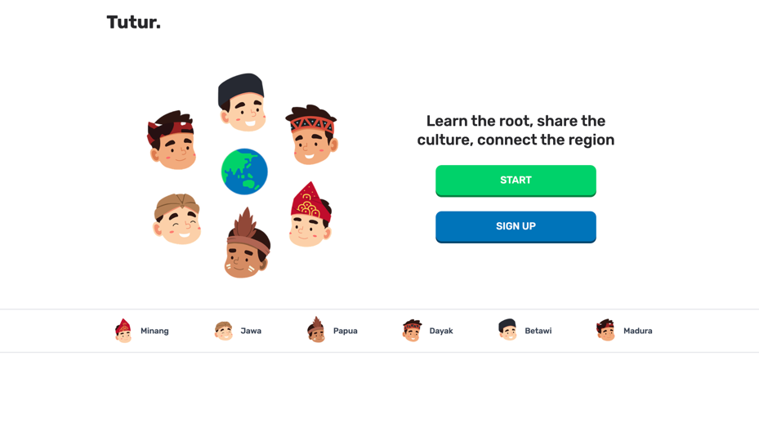
Figure 1. Landing Page
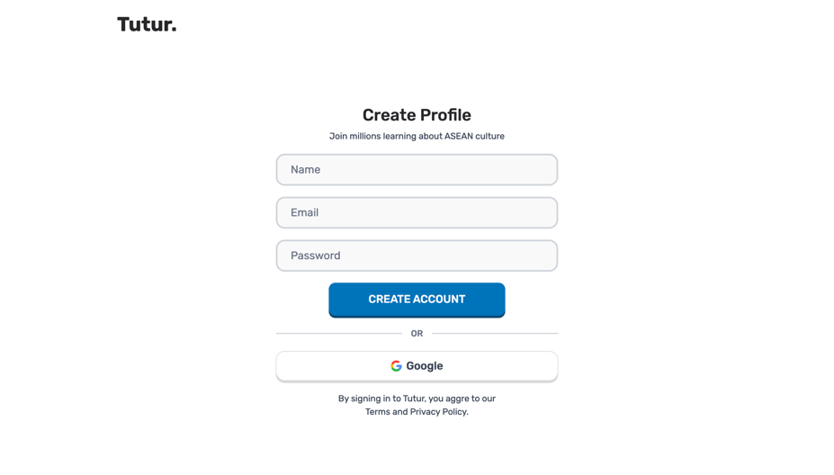
Figure 2. Registration Page
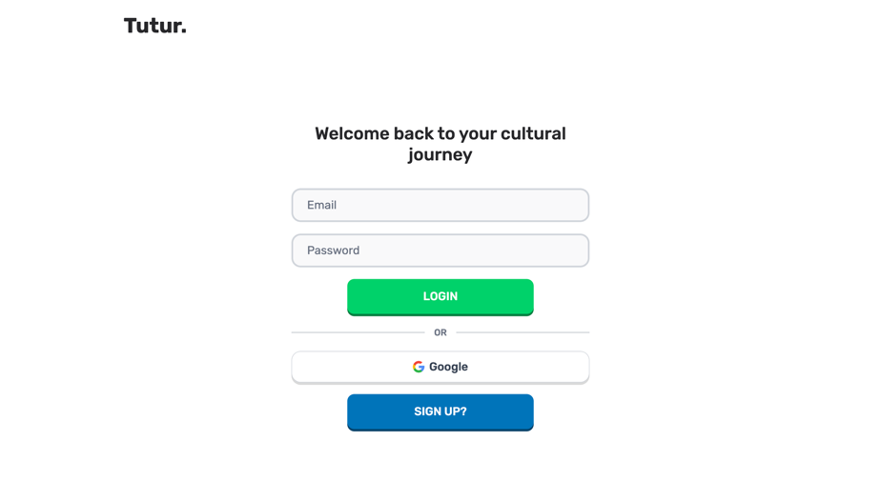
Figure 3. Login Page
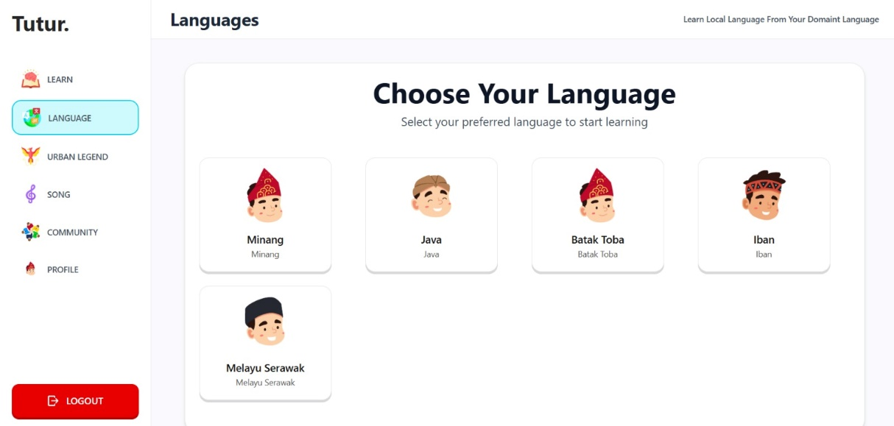
Figure 4. Language Module Main Page
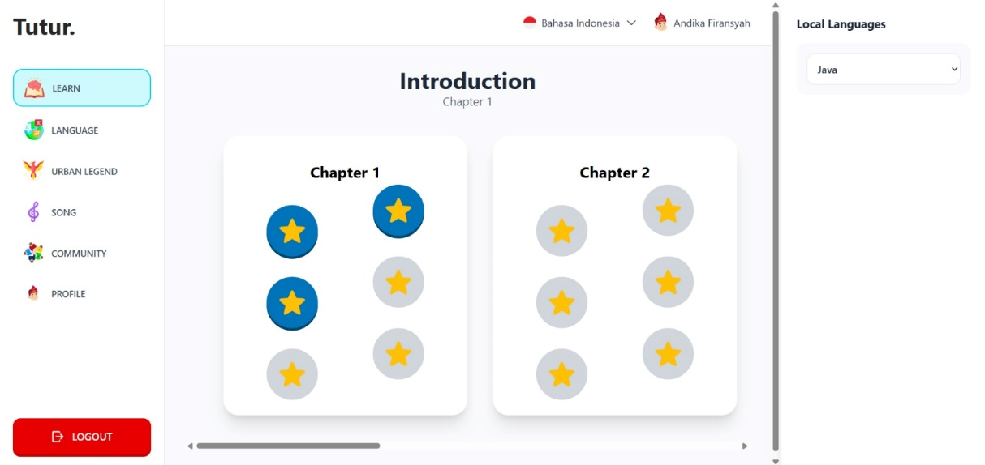
Figure 5. Language Learning Main Page
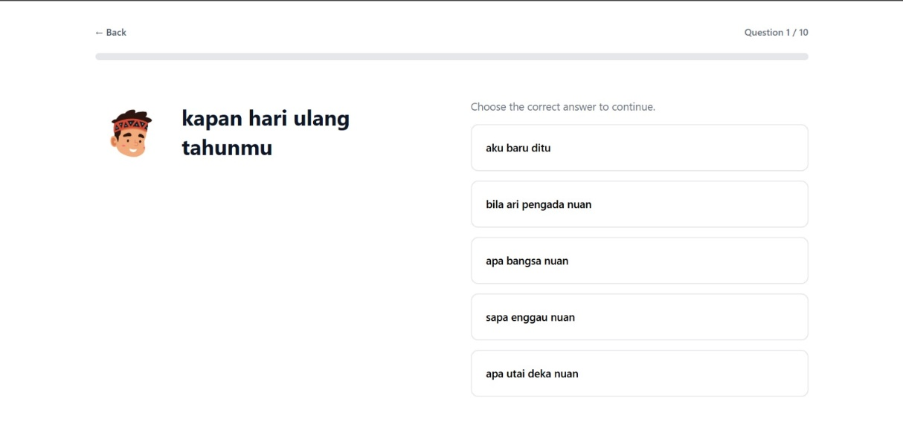
Figure 6. Learning Question Page
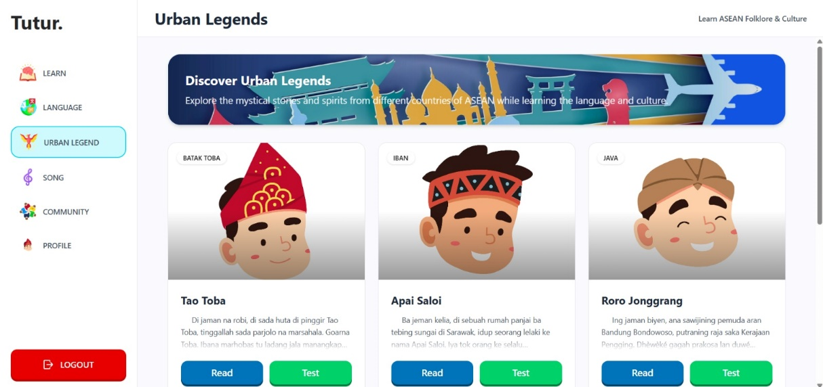
Figure 7. Folktale Module Main Page
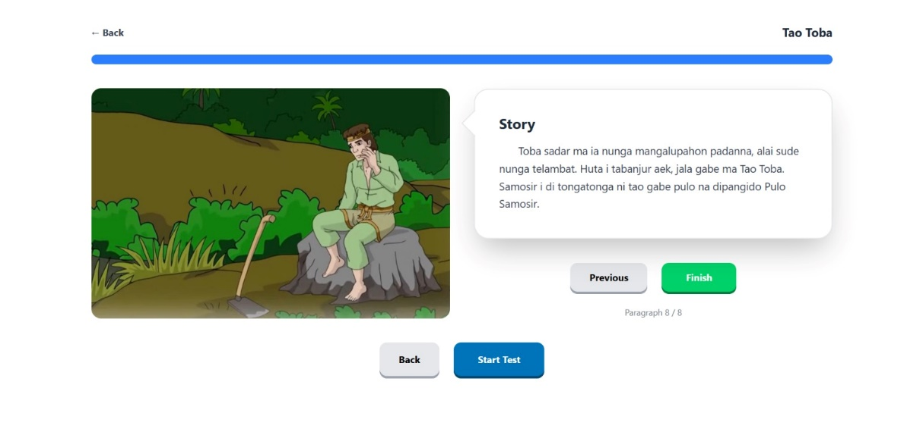
Figure 8. Folktale Learning Page
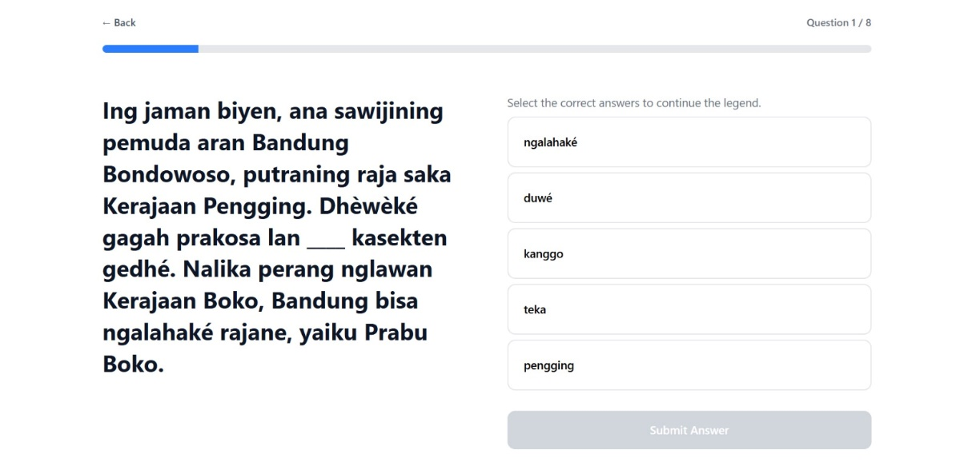
Figure 9. Folktale Learning Question Page
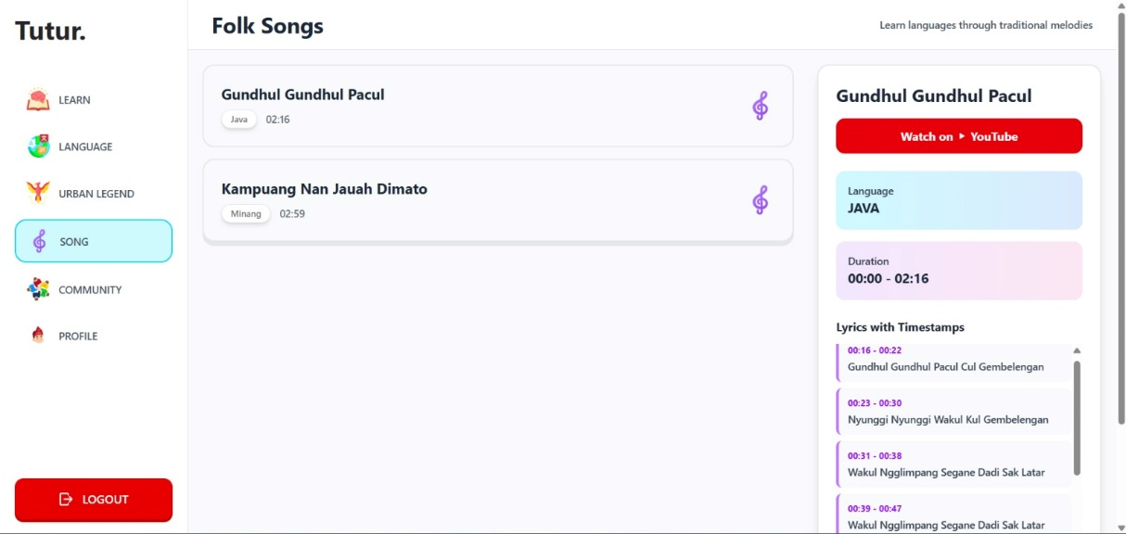
Figure 1. Folk Song Module Main Page
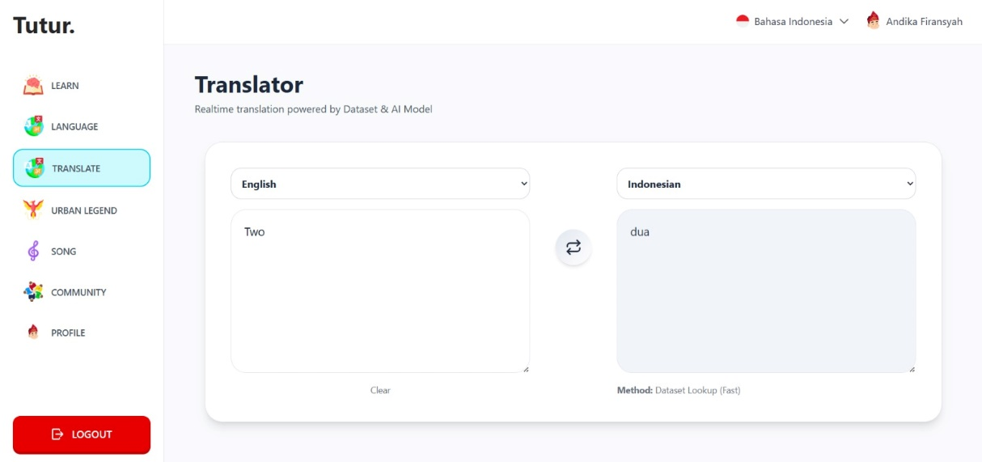
Figure 2. Language Translate Tools Page
- AI Acknowledgement (Mandatory Disclosure)
  - AI Tools Disclosure
As part of full compliance with the regulations of the BorNEO HackWknd 2026, the following AI tools were used during the development of Tutur. We affirm that all disclosed usage represents legitimate development assistance and does not constitute fabrication of original work.

AI Tools | Category | Usage
Gemini | Code Assistance | Assisted with debugging Next.js component logic and designing MySQL schemas and NLP models.

  - AI Ethics Statement
All AI-generated code and assets were reviewed, validated, and modified by human team members before being integrated into the system. The core intellectual contributions including curriculum design, language model training strategy, cultural content curation, and system architecture are original work produced by the MiDev team. AI tools were used to accelerate implementation, not to replace original thinking or human creativity.

- Conclusion
  - Project Summary
Tutur represents a meaningful technological response to one of the most urgent cultural challenges in Southeast Asia: the digital invisibility of indigenous languages. By building an AI-powered language learning platform inspired by platforms such as Duolingo and other language-learning applications, Tutur supports eight regional languages Malay, Indonesian, English, Minangkabau, Javanese, Batak Toba, Iban, and Sarawak Malay. Through this platform, language preservation is transformed from passive archival efforts into an active, participatory, and engaging daily practice. Within the timeframe of the hackathon, the team successfully delivered a functional prototype with all core features implemented, including: User authentication, Language selection, Tiered learning modules, Four types of exercises: Text-based Q&A, Folktale learning, Word matching, and Listening training. Our NLP backend is fully operational, enabling the system to evaluate learner responses in low-resource ASEAN languages, where no commercial alternatives currently exist.
  - Future Improvements
The Tutur roadmap extends far beyond the current prototype. Planned future developments include:
- Native Speaker Community Hub : A structured platform connecting learners with fluent native speakers for live conversation practice, content contributions, and mentorship, transforming Tutur into a living language ecosystem.
- Offline & Low-Bandwidth Mode : Progressive Web App (PWA) caching for offline lesson access, ensuring usability in rural ASEAN communities with unstable connectivity, directly addressing digital divide challenges.
- Language Certification System : Official language proficiency certificates recognized by educational institutions and employers, providing tangible credibility for regional language skills.
- Language Coverage Expansion : Addition of more ASEAN indigenous languages, including Kadazan-Dusun, Orang Ulu dialects, and other Borneo languages in future development phases.
- AI Voice Synthesis : Text-to-speech capabilities featuring authentic regional accents, generated from models fine-tuned using native speaker recordings to preserve phonetic nuances that text alone cannot convey.
- Gamification Expansion : Implementation of leaderboards, language challenges, community achievements, and daily streak systems to maximize long-term learner engagement.
- B2B Partnerships : Integration partnerships with schools, universities, and cultural institutions across ASEAN, enabling Tutur to be adopted as a supplementary curriculum tool for mother-tongue language programs.

  - Closing Statement
Our Vision

“Every language carries a unique way of understanding the world. When a language dies, humanity loses a perspective that can never be recovered. Tutur exists to ensure that the voices of Minangkabau elders, Iban storytellers, Batak Toba poets, and Sarawak community leaders do not fall silent in the digital era. We believe that technology when built with humility toward culture and genuine community partnership can become the greatest ally of indigenous languages. Tutur is not merely an application; it is a commitment to the irreplaceable linguistic diversity of ASEAN.”

References

Crystal, D. (2000). Kematian Bahasa. Cambridge: Cambridge University Press.
Fishman, JA (1991). Membalikkan Pergeseran Bahasa: Landasan Teoretis dan Empiris Bantuan untuk Bahasa-Bahasa yang Terancam Punah. Clevedon: Multilingual Matters.
Goldhahn, D., Eckart, T., & Quasthoff, U. (2012). Membangun kamus monolingual besar di Koleksi Korpus Leipzig: Dari 100 menjadi 200 bahasa. Prosiding Konferensi Internasional Kedelapan tentang Sumber Daya dan Evaluasi Bahasa (LREC 2012). Asosiasi Sumber Daya Bahasa Eropa.
HolonIQ. (2023). Laporan Pasar EdTech Asia Tenggara 2023. Platform Intelijen HolonIQ.
Moseley, C. (Ed.). (2010). Atlas Bahasa-Bahasa Dunia yang Terancam Punah (edisi ke-3). Paris: Penerbitan UNESCO.
Simons, GF, & Fennig, CD (Eds.). (2023). Ethnologue: Bahasa-Bahasa Dunia (edisi ke-26). Dallas, TX: SIL International. Diperoleh dari https://www.ethnologue.com
Sweeney, A. (1987). Mendengarkan Sepenuhnya: Lisanitas dan Literasi di Dunia Melayu. Berkeley: University of California Press.
UNESCO. (2003). Konvensi untuk Perlindungan Warisan Budaya Takbenda. Paris: UNESCO. Diperoleh dari https://ich.unesco.org
We Are Social & Hootsuite. (2024). Digital 2024: Laporan Gambaran Umum Regional Asia Tenggara. We Are Social Ltd.

